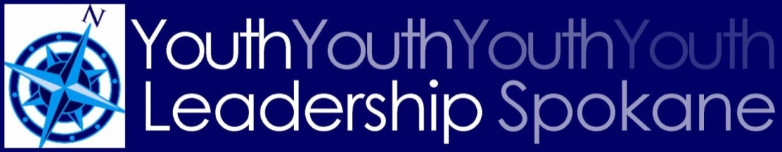

Schedule for 2018-2019 YLS
Locations TBA
Retreat Thursday, August 16
Public Safety September 24
Human Needs October 29
Diversity November 26
Communication December 17
Arts January 14
Financial Education February 25
Governance March 25
Healthy Communities April 29
Stepping Up May 20
Commencement Second week of June

Leadership Spokane, 801 W. Riverside Ave., Suite 220, Spokane WA 99201 | 509-321-3639 | www.leadershipspokane.org

